FALCON FEVER WEEK JAN.-30TH- FEB. 3RD
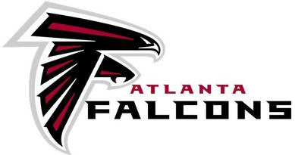 RISE UP- WIN WITHIN
Monday-
Did you know there are 13 teams to have never ever won the super bowl? There’s nine teams who have gone and come away with no win. The Arizona Cardinals, Atlanta Falcons, Carolina Panthers, San Diego Chargers, and Tennessee Titans have each lost a super bowl, while Cincinnati Bengals and Philadelphia Eagles are 0- for- 2.

Tuesday-
Who is the Falcons Owner? Arthur Blank. He is also an American Businessman and Co-Founder of the Home Depot. Today he is known for his Philanthropy, his ownership of the Atlanta Falcons in the National Football League, and his ownership of Atlanta United in Major League Soccer.

Wednesday-
Did you know that the Falcons v/s Packer game was the last Falcons home game in the Georgia Dome, before their new home in the Mercedes-Benz Stadium?

Thursday-
Did you know that Dan Quinn, Falcons Head Coach since 2015, was the assistant head coach and defensive line coach of the Seattle Seahawks 2013-2014 season?

Friday-
Did you know that Matthew Thomas Ryan, Quarterback for the Atlanta Falcons played several sports in high school? He played football (quarter-back), basketball (small forward) and baseball (pitcher and shortstop) in high school.

